

**International School**

**Software Process & Quality Management**

**CMU-SE 433 SAIS**

**User Interface Design**

**Version 1.1**

**Date: 30 Jun 2025**

**Hotel Management System**

**Submitted by**

**Lanh, Do**

**Quyen, Truong Thi My**

**Hoang, Le Huy**

**Quoc, Pham Tan**

**Hung, Duong Van**

**Approved by**

**MSc Huy, Truong Dinh**

**User Interface Design Review Panel Representative:**

Name Signature Date

**Software Process & Quality Management - Mentor:**

Name Signature Date

**PROJECT INFORMATION**

|  |  |  |  |  |
| --- | --- | --- | --- | --- |
| **Project acronym** | HMS | | | |
| **Project Title** | Hotel Management System | | | |
| **Start Date** | 12 Jun 2025 | | **End Date** | July 23, 2025 |
| **Lead Institution** | International School, Duy Tan University | | | |
| **Project Mentor** | MSc. Duc, Nguyen Manh | | | |
| **Scrum master / Project Leader & contact details** | Lanh, Do  Email: ddolanh0@gmail.com  Tel: 0936212369 | | | |
| **Partner Organization** | Duy Tan University | | | |
| **Project Web URL** |  | | | |
| **Team members** | Name | Email | | Tel |
| 28219129939 | Lanh, Do | ddolanh0@gmail.com | | 0936212369 |
| 28201100757 | Quyen, Truong Thi My | thanhmieu2112@gmail.com | | 0768585726 |
| 28219027592 | Hoang, Le Huy | lehuyhoang123789@gmail.com | | 0935563105 |
| 28212306085 | Quoc, Pham Tan | phamtanquoc1@gmail.com | | 0763739254 |
| 28210201891 | Hung, Duong Van | hd795033@gmail.com | | 0334231904 |

**DOCUMENT APPROVALS**

The following signatures are required for approval of this document.

|  |  |  |
| --- | --- | --- |
| Lanh, Do  Student ID: 28219129939  *Scrum Master* | Signature | Date |
| Quyen, Truong Thi My  Student ID: 28201100757  *Team Member* | Signature | Date |
| Hoang, Le Huy  Student ID: 28219027592  *Team Member* | Signature | Date |
| Quoc, Pham Tan  Student ID: 28212306085  *Team Member* | Signature | Date |
| Hung, Duong Van  Student ID: 28210201891  *Team Member* | Signature | Date |

REVISION HISTORY

| **Version** | **Date** | **Comments** | **Author** |
| --- | --- | --- | --- |
| 1.0 | 30 Jun 2025 | Initial Release | Đỗ Lanh |

**TABLE OF CONTENT**

1. Introduction .......................................................................................................7

1.1. Purpose .......................................................................................................7

1.2. Scope ..........................................................................................................7

2. Interface Design ................................................................................................7

2.1. Control Panel.................................................................................................7

2.2. Book a room..................................................................................................9

2.3. Client............................................................................................................10

2.4. Service..........................................................................................................11

2.5. Staff…..........................................................................................................12

2.6. Report...........................................................................................................13

2.7. System settings..............................................................................................14

TABLE OF FIGURES

Firure 1. Control Panel……………………………………………………..…………..7

Firure 2. Book a room………………………………………………………………….9  
Firure 3. Client…………………………………………………………………...……10

Firure 4. Service……………………………………………………..………………...11

Firure 5. Staff.…………………………………………………………………………12

Firure 6. Report………………………………………………………………………..13

Firure 7. System settings……………………………………………………………....14

**TABLE OF TABLES**

Table 1. Control Panel……………………………………………………...……………8

Table 2. Book a room……………………………………………………………………9

Table 3. Client………………………………………………………………………….10

Table 4. Service…………………………………………………………………………11

Table 5. Staff…………………………………………………………………………….12

Table 6. Report…………………………………………………..………………………13

Table 7. System settings…………………………………………………………………14

**1. Introduction**

**1.1. Purpose**

This specification covers the following:

- Documentation helps to better understand the user interface of the website, the detailed description and functionality of the website.

- With this documentation, the development team can understand the structure and composition details to create a consistent and complete system.

**1.2. Scope**

- Overview of the stages and modules of the software.

- Create complete interface and describe them clearly.

**2. Interface Design**

**2.1.** **Control Panel**

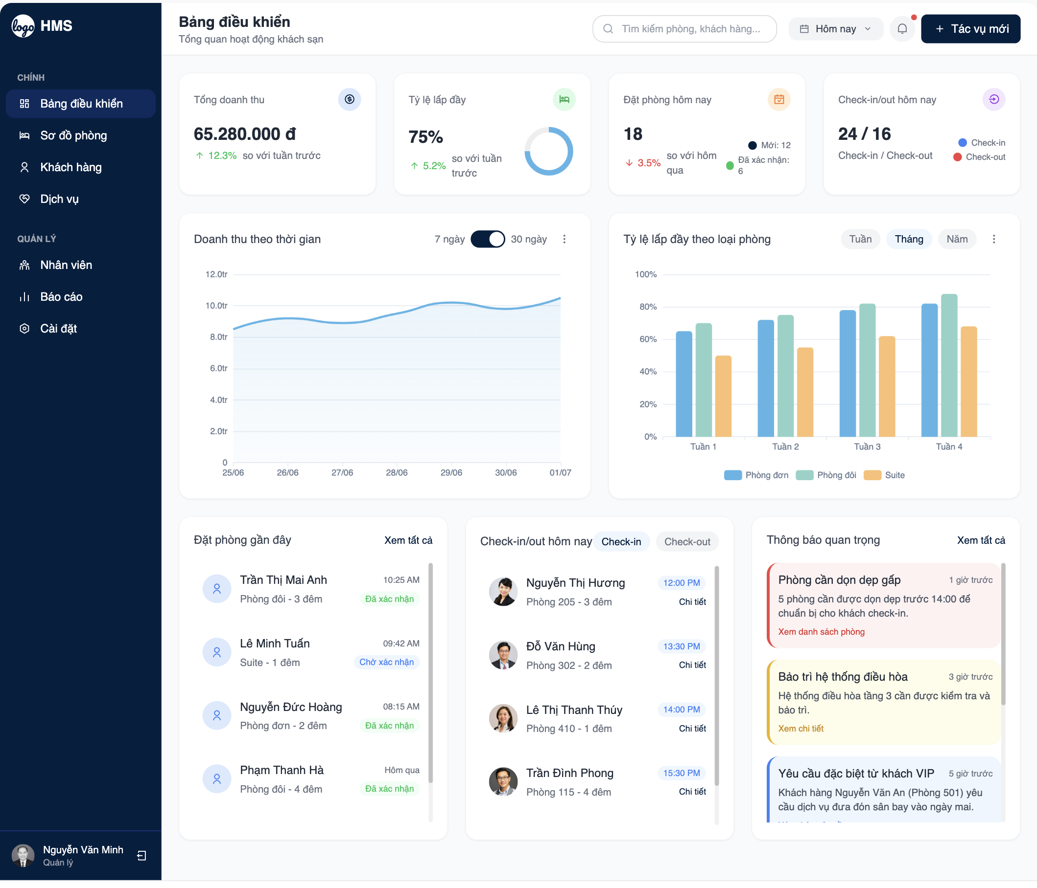

Firure 1. *Control Panel*

**Table 1.** *Control Panel*

|  |  |  |  |  |
| --- | --- | --- | --- | --- |
| Control Panel | | | | |
| No. | Field name | Type | Require | Target |
| 1 | Dashboard Title | H1 tag | Font-size: 24px; Font-family: "Source Sans Pro"; Color: #101522 | Display main dashboard title |
| 2 | Summary Widgets | Grid view | Background: #f5f5f5; Padding: 15px; Font-size: 14px | Show key metrics (e.g., occupancy rate, revenue) |
| 3 | Quick Actions | Button | Background: blue; Color: #fff; Font-size: 14px | Quick access to booking, check-in, check-out |
| 4 | Navigation Menu | List | Height: 50px; Font-size: 16px; Responsive: max-width: 960px | Links to Book a Room, Client, Service, Staff, Report, Settings |
| 5 | User Profile | Image | Width: 40px; Height: 40px; Border-radius: 50% | Display logged-in user’s avatar |
| 6 | Notifications | Icon | Font-size: 18px; Color: red | Show unread notifications count |
| 7 | Search Bar | Input | Width: 200px; Font-size: 14px; Border: 1px solid #ccc | Search across system modules |

**2.2.** **Book a room**

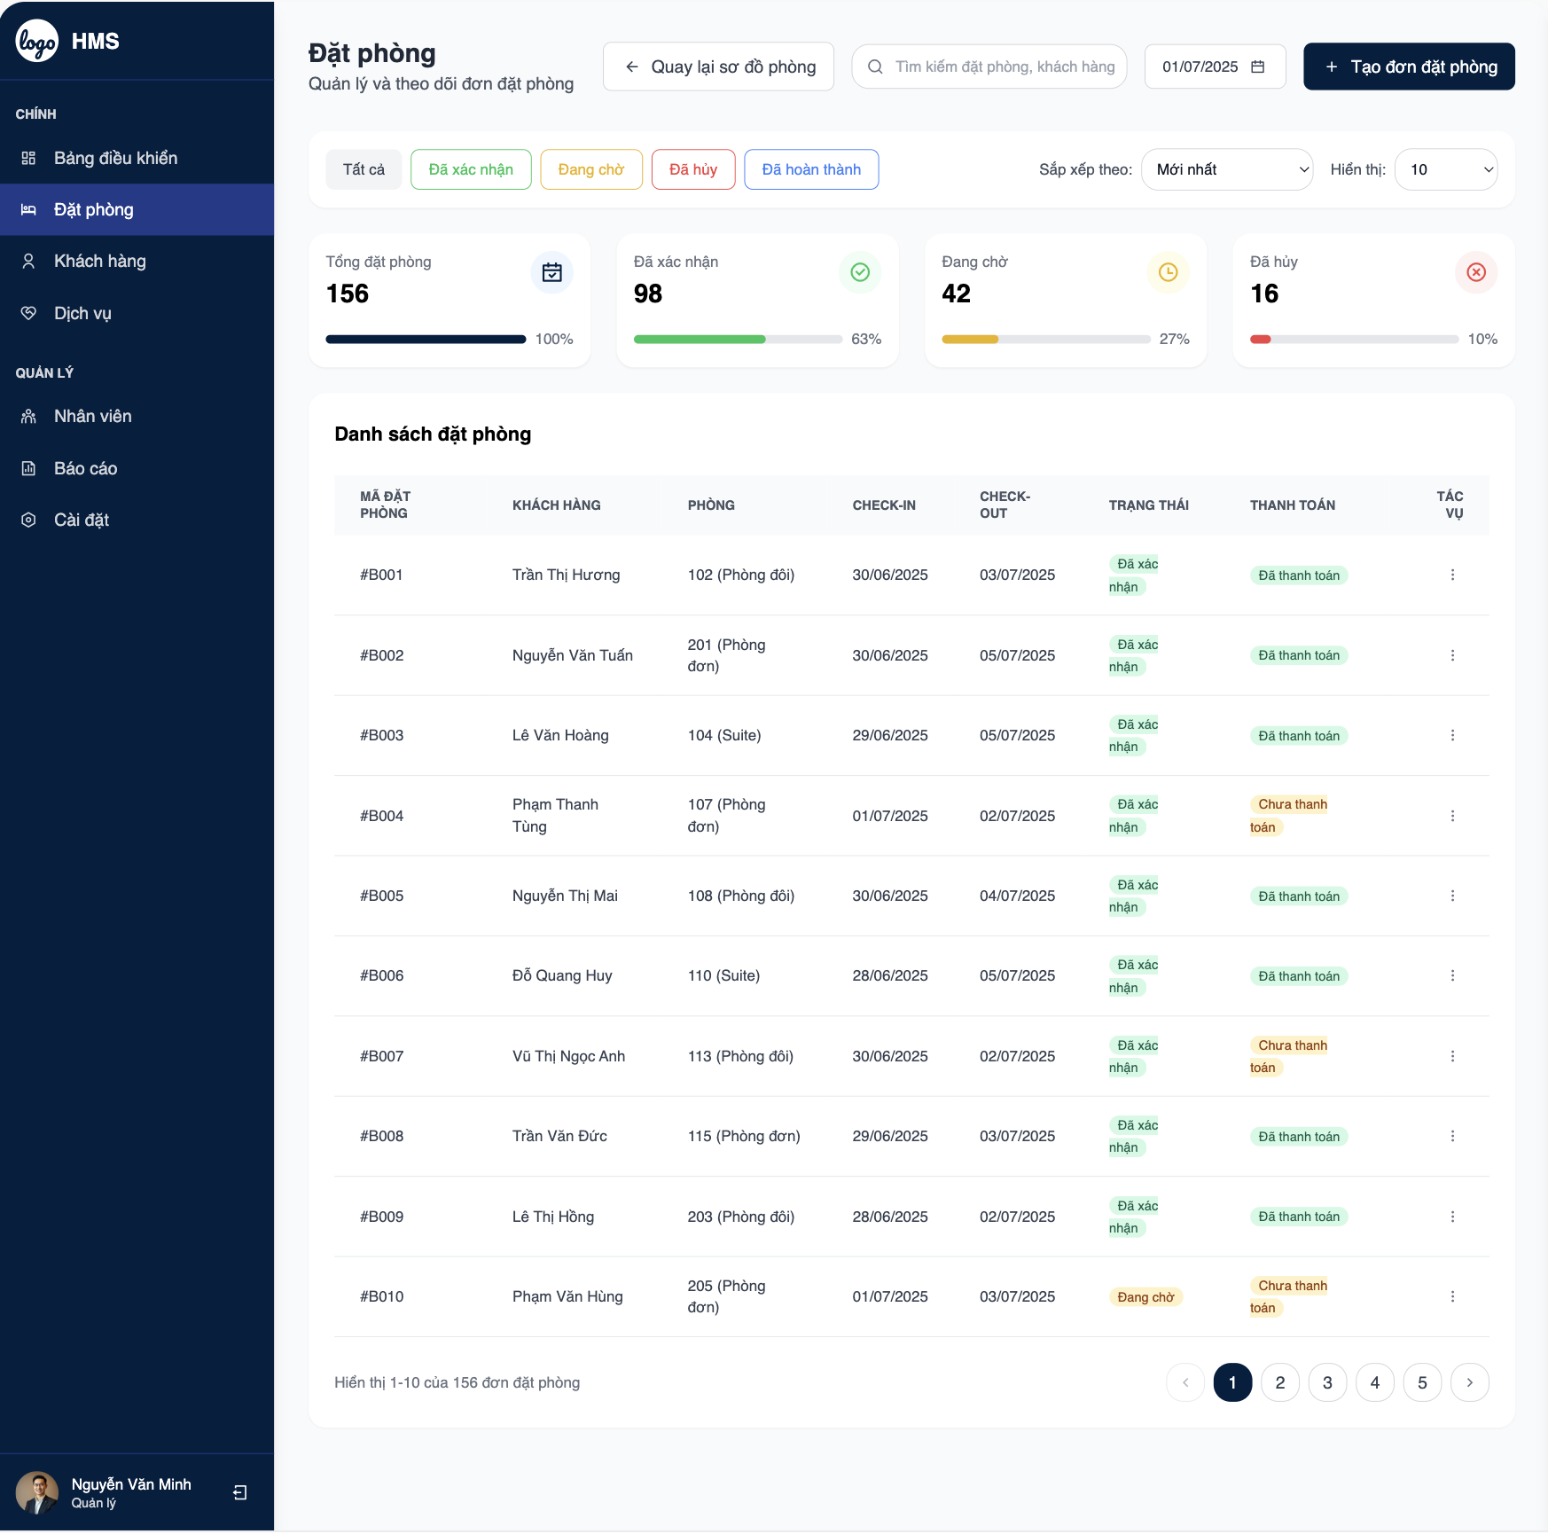

Firure 2. *Book a room*Table 2. *Book a room*

|  |  |  |  |  |
| --- | --- | --- | --- | --- |
| Book a room | | | | |
| No. | Field name | Type | Require | Target |
| 1 | Section Title | H1 tag | Font-size: 20px; Color: blue | Display "Book a Room" title |
| 2 | Room Type | Dropdown | Font-size: 14px; Width: 200px | Select room type (e.g., Single, Double, Suite) |
| 3 | Check-in Date | Input | Type: date; Font-size: 14px | Select check-in date |
| 4 | Check-out Date | Input | Type: date; Font-size: 14px | Select check-out date |
| 5 | Guest Details | Input | Font-size: 14px; Width: 300px | Enter guest name and contact info |
| 6 | Confirm Booking | Button | Background: blue; Color: #fff; Font-size: 14px | Submit booking request |
| 7 | Availability Status | P tag | Font-size: 13px; Color: green | Display room availability |

2.3 Client

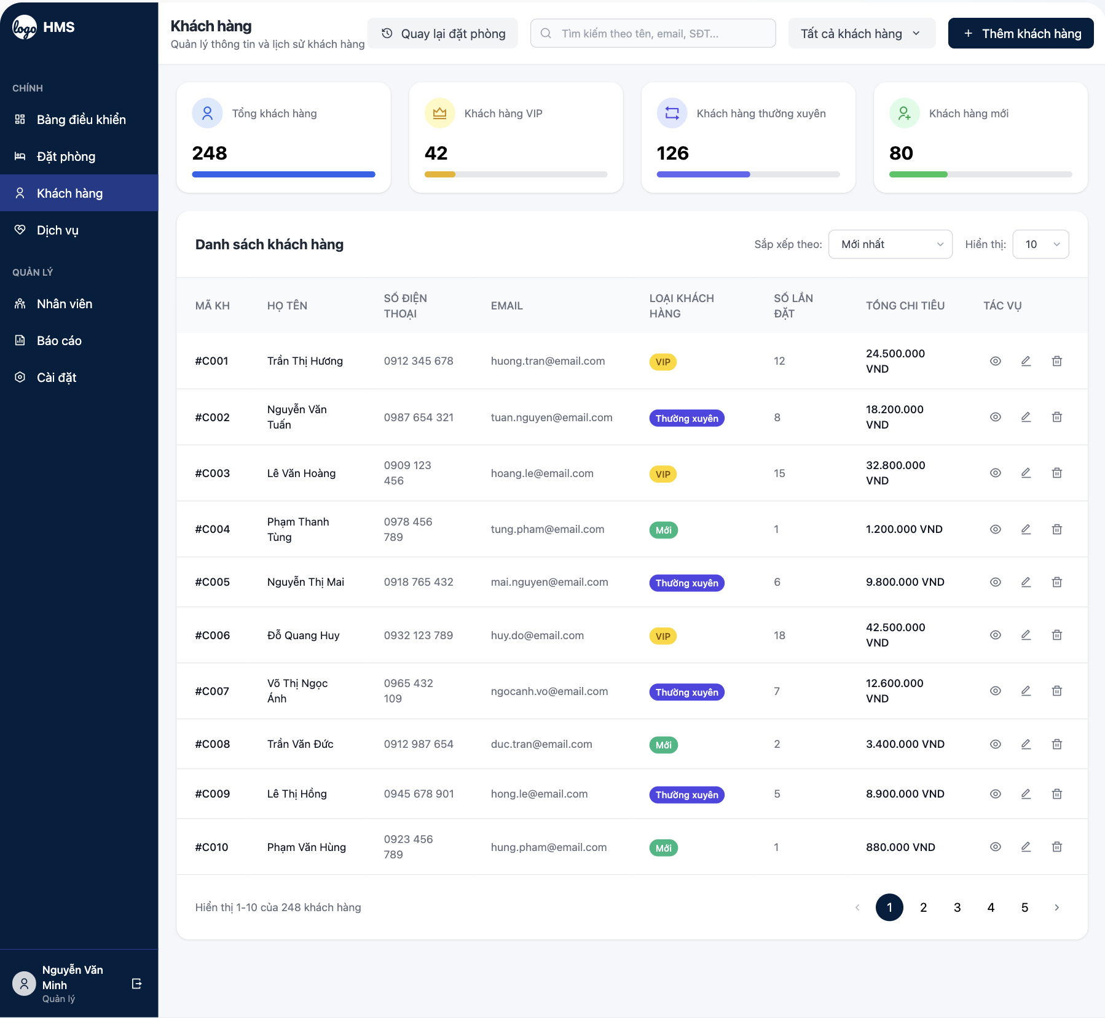

**Firure 3.***Client*

**Table 3.** *Client*

|  |  |  |  |  |
| --- | --- | --- | --- | --- |
| Client | | | | |
| No. | Field name | Type | Require | Target |
| 1 | Client List Title | H1 tag | Font-size: 20px; Color: blue | Display "Client List" title |
| 2 | Client Name | P tag | Font-size: 14px; Font-weight: bold | Show client full name |
| 3 | Client Contact | P tag | Font-size: 13px | Display client email and phone |
| 4 | Booking History | List | Font-size: 13px; Padding: 10px | Show past and current bookings |
| 5 | Edit Client | Button | Background: blue; Color: #fff; Font-size: 14px | Edit client details |
| 6 | Add Client | Button | Background: green; Color: #fff; Font-size: 14px | Add new client to system |
| 7 | Search Client | Input | Width: 200px; Font-size: 14px | Search clients by name or ID |

2.4 Service

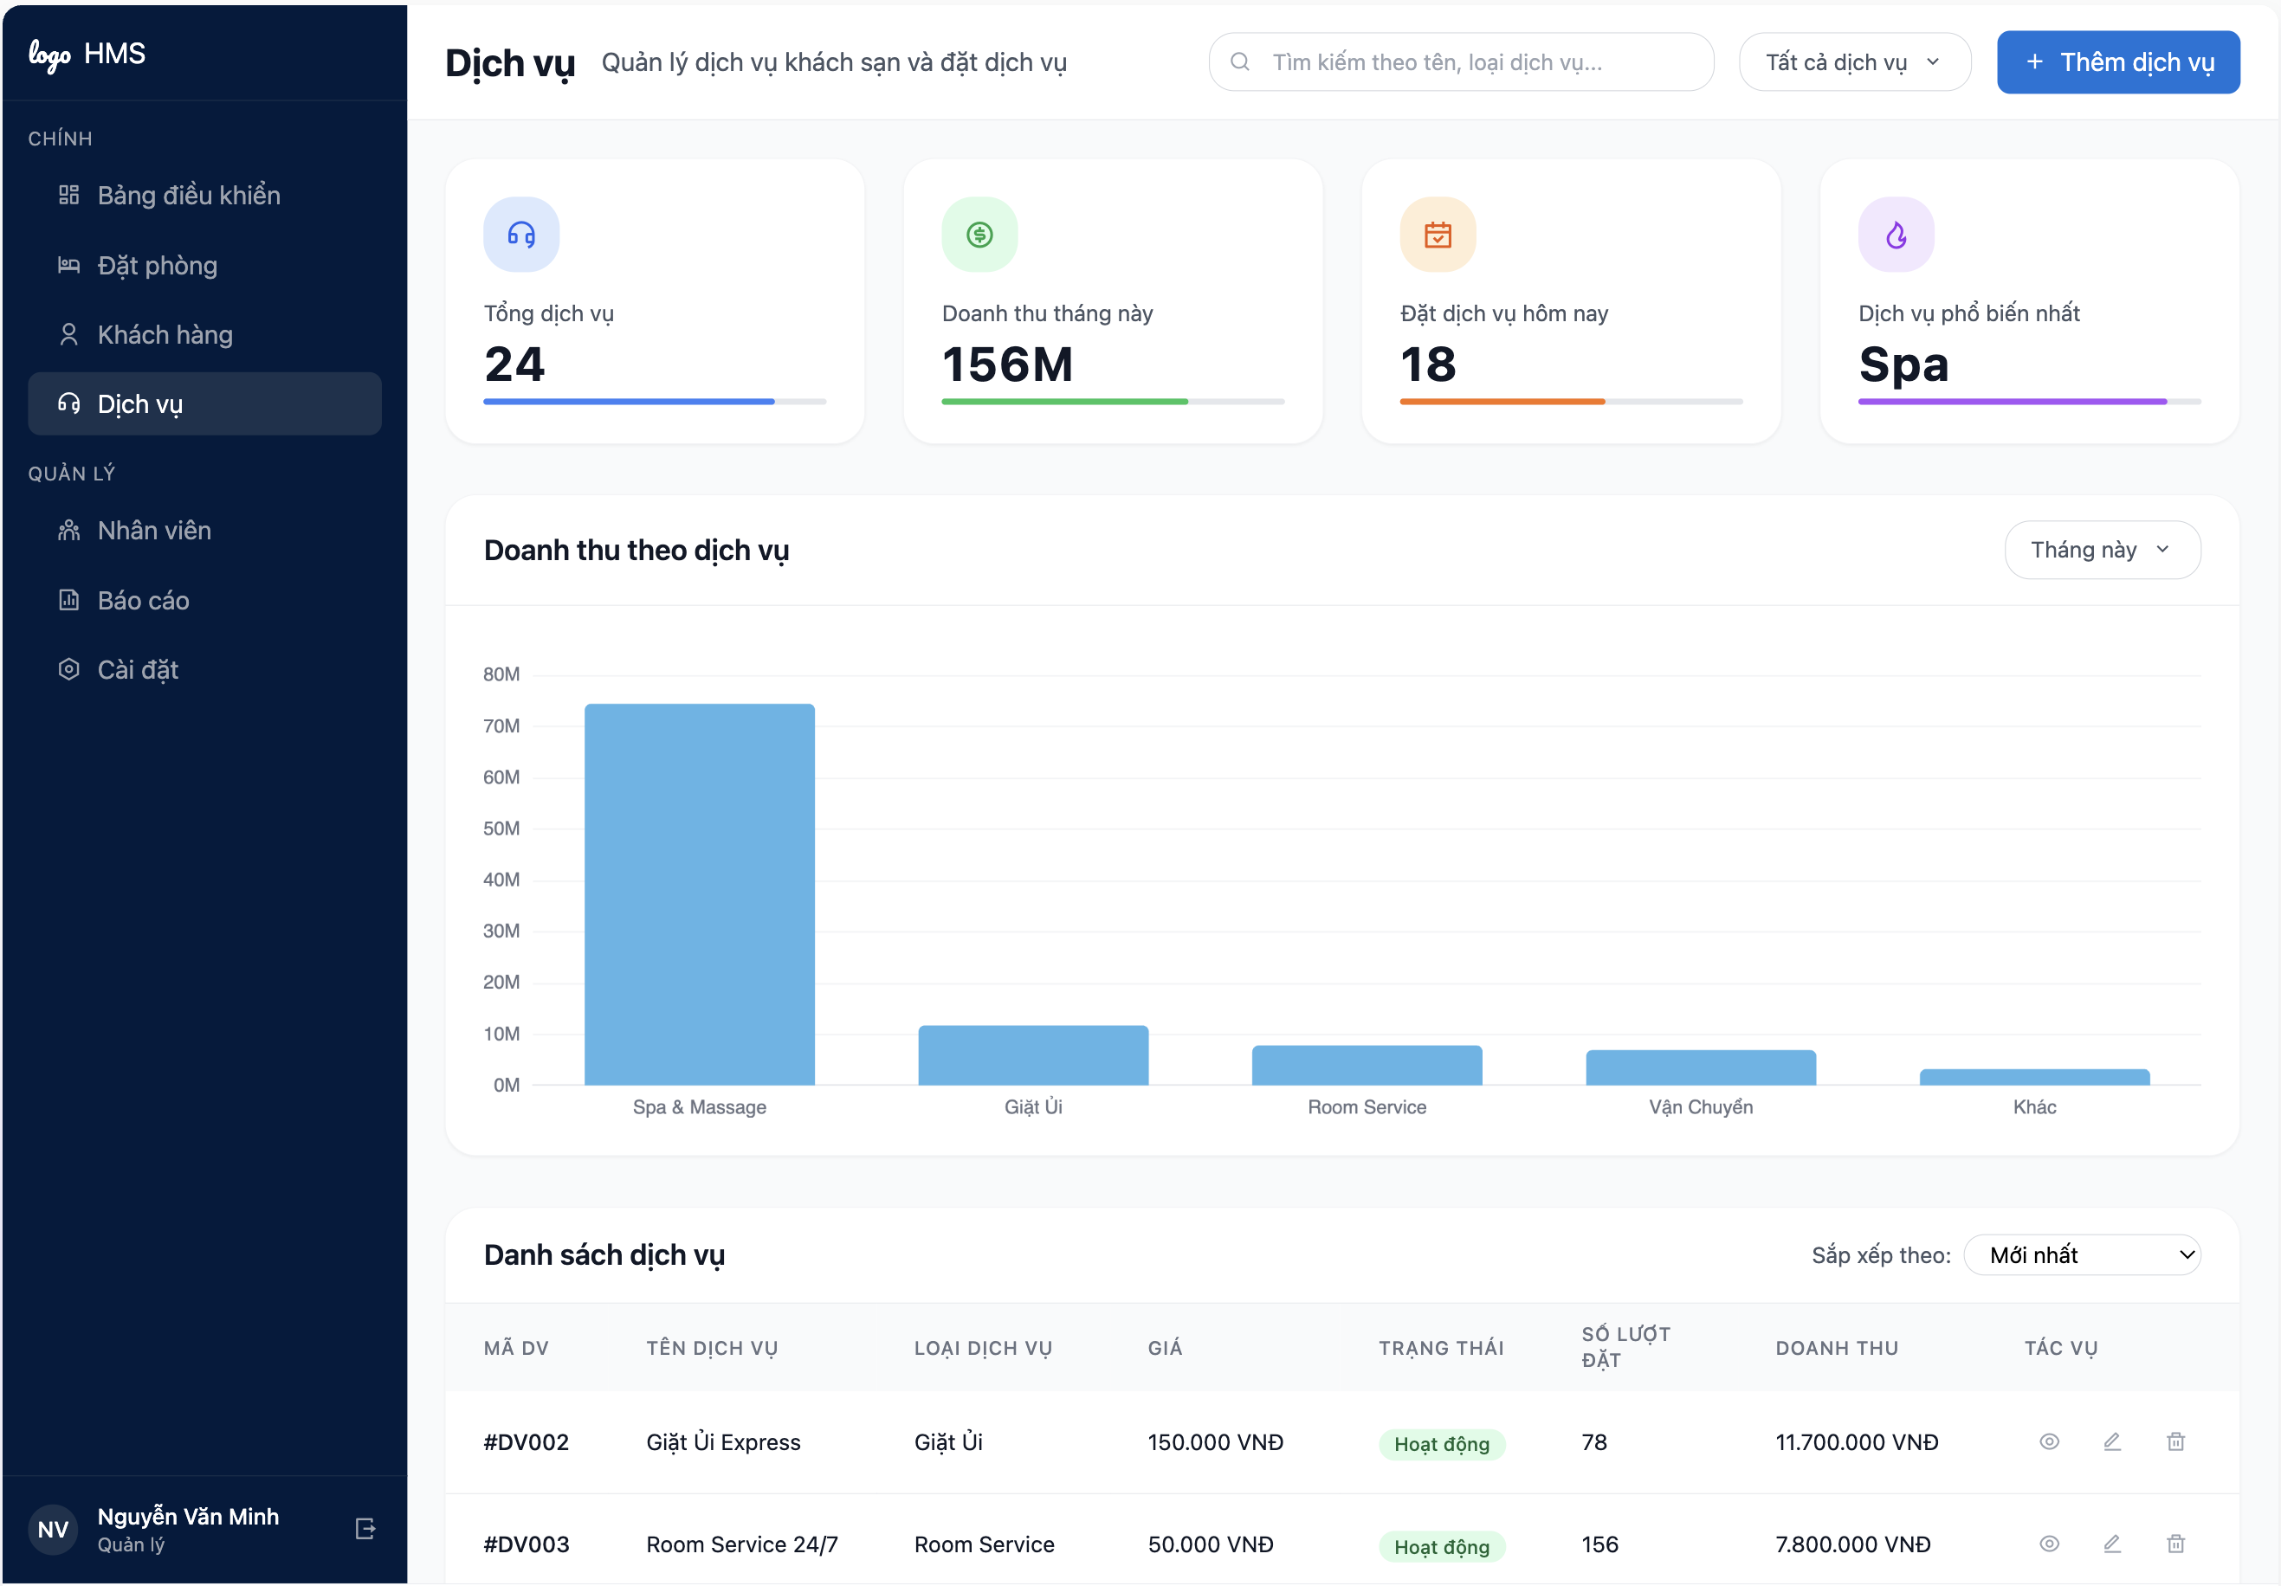

**Firure 4.** *Service*  
  
**Table 4.** *Service*

|  |  |  |  |  |
| --- | --- | --- | --- | --- |
| Service | | | | |
| No. | Field name | Type | Require | Target |
| 1 | Service Title | H1 tag | Font-size: 20px; Color: blue | Display "Services" title |
| 2 | Service Name | P tag | Font-size: 14px; Font-weight: bold | Show service name (e.g., Room Service, Spa) |
| 3 | Service Price | P tag | Font-size: 13px | Display service cost |
| 4 | Service Availability | P tag | Font-size: 13px; Color: green | Show service availability status |
| 5 | Add Service | Button | Background: green; Color: #fff; Font-size: 14px | Add new service to system |
| 6 | Edit Service | Button | Background: blue; Color: #fff; Font-size: 14px | Edit existing service details |
| 7 | Service Request | Button | Background: orange; Color: #fff; Font-size: 14px | Request service for a client |

2.5 Staff

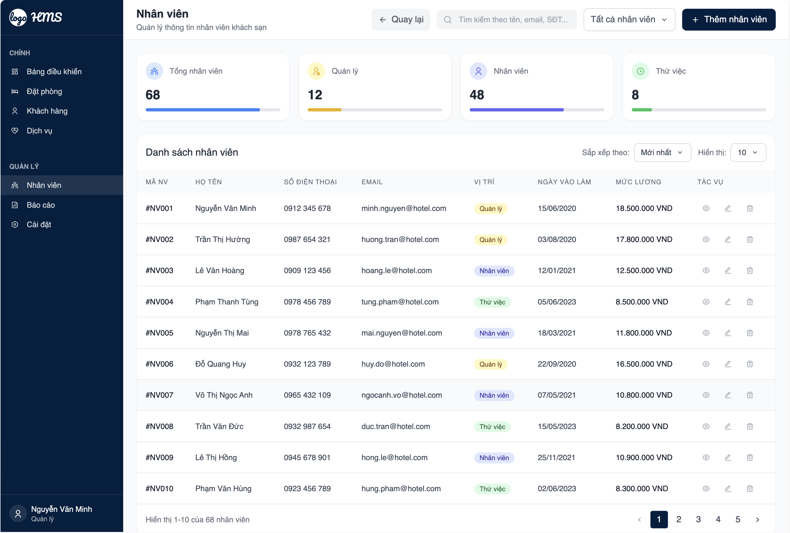

**Firure 5.** *Staff*  
  
**Table 5.** *Staff*

|  |  |  |  |  |
| --- | --- | --- | --- | --- |
| Staff | | | | |
| No. | Field name | Type | Require | Target |
| 1 | Staff List Title | H1 tag | Font-size: 20px; Color: blue | Display "Staff List" title |
| 2 | Staff Name | P tag | Font-size: 14px; Font-weight: bold | Show staff full name |
| 3 | Staff Role | P tag | Font-size: 13px | Display staff role (e.g., Receptionist, Manager) |
| 4 | Staff Contact | P tag | Font-size: 13px | Show staff email and phone |
| 5 | Add Staff | Button | Background: green; Color: #fff; Font-size: 14px | Add new staff member |
| 6 | Edit Staff | Button | Background: blue; Color: #fff; Font-size: 14px | Edit staff details |
| 7 | Staff Schedule | List | Font-size: 13px; Padding: 10px | Show staff work schedule |

2.6 Report

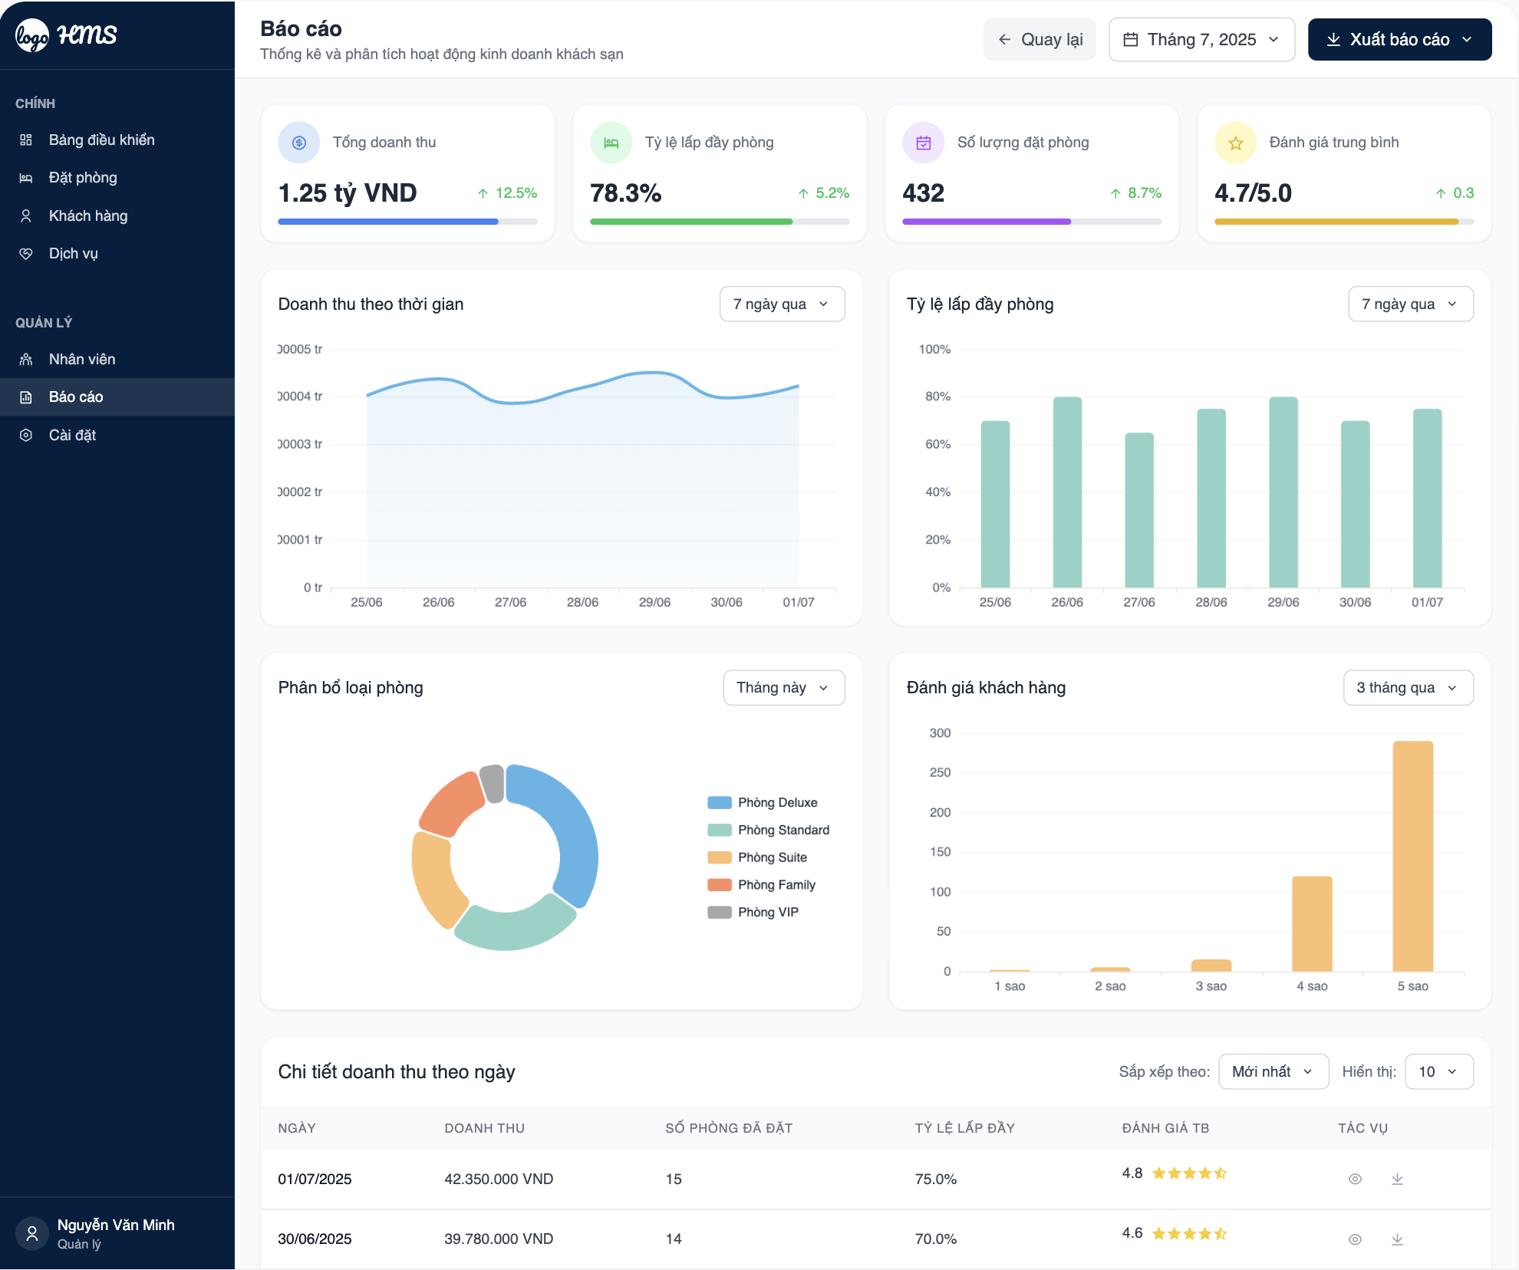

**Firure 6.** *Report*

**Table 6.** *Report*

|  |  |  |  |  |
| --- | --- | --- | --- | --- |
| Report | | | | |
| No. | Field name | Type | Require | Target |
| 1 | Report Title | H1 tag | Font-size: 20px; Color: blue | Display "Reports" title |
| 2 | Report Type | Dropdown | Font-size: 14px; Width: 200px | Select report type (e.g., Revenue, Occupancy) |
| 3 | Date Range | Input | Type: date; Font-size: 14px | Select report date range |
| 4 | Generate Report | Button | Background: blue; Color: #fff; Font-size: 14px | Generate selected report |
| 5 | Report Data | Table | Font-size: 13px; Border: 1px solid #ccc | Display report data in table format |
| 6 | Export Report | Button | Background: green; Color: #fff; Font-size: 14px | Export report as PDF or CSV |
| 7 | Filter Options | Input | Font-size: 14px; Width: 150px | Filter report by specific criteria |

2.7 System settings

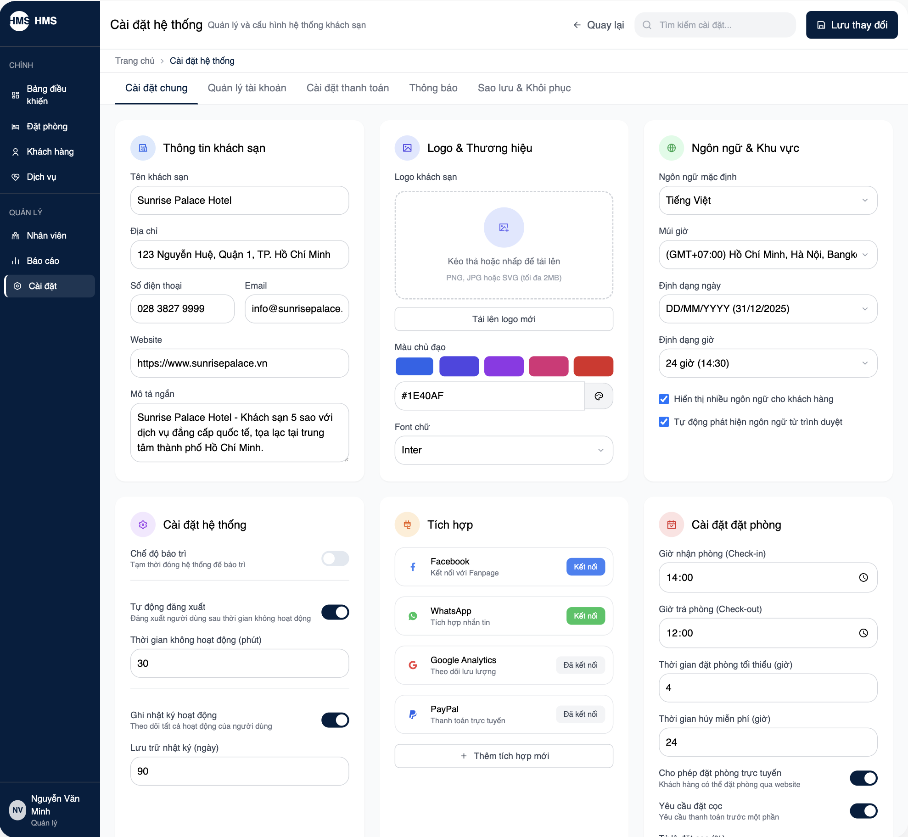

**Firure 7.** *System settings*

**Table 7.** *System settings*

|  |  |  |  |  |
| --- | --- | --- | --- | --- |
| System settings | | | | |
| No. | Field name | Type | Require | Target |
| 1 | Settings Title | H1 tag | Font-size: 20px; Color: blue | Display "System Settings" title |
| 2 | Hotel Info | Input | Font-size: 14px; Width: 300px | Edit hotel name, address, contact |
| 3 | User Roles | List | Font-size: 13px; Padding: 10px | Manage user roles and permissions |
| 4 | Save Settings | Button | Background: blue; Color: #fff; Font-size: 14px | Save changes to settings |
| 5 | Currency | Dropdown | Font-size: 14px; Width: 150px | Select system currency |
| 6 | Language | Dropdown | Font-size: 14px; Width: 150px | Select system language |
| 7 | Backup Data | Button | Background: orange; Color: #fff; Font-size: 14px | Initiate system data backup |